Main/Final
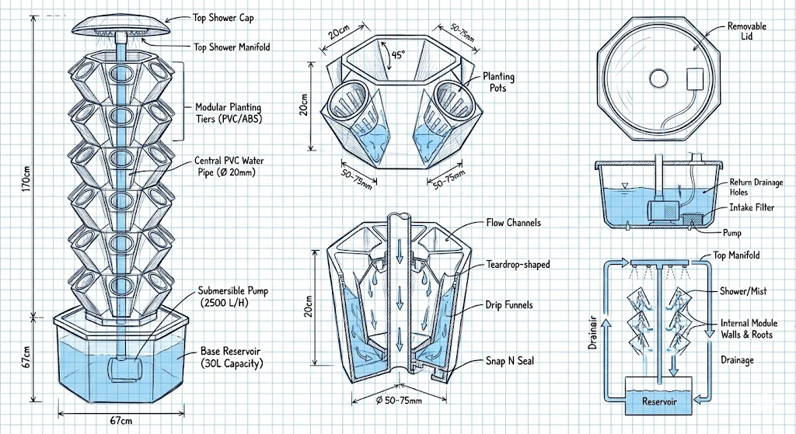

Shopping list
- PETG (used for the tower)
- Ultrasonic Mist Sprayer (Tim’s Idea)
- Bolts and nuts if needed
- Materials for DIY turntable (for rotating base, Lazy Susan style)
- Motor
- Arduino (or any other for controlling)
- Wires
- Water tubes
- Metal shafts for support if needed
- Sponges
- Sensors to monitor plant; if needed (pH sensors, CO2 sensors, Humidity and Temperature sensor)

https://www.amazon.ca/ZORZA-Four-Spray-Humidifier-Versatile-Atomizer/dp/B0CYZJR2G4/ref=asc_df_B0CYZJR2G4?mcid=a1189d1f8b3a3cb68a25e30090b41787&tag=googleshopc0c-20&linkCode=df0&hvadid=706745545657&hvpos=&hvnetw=g&hvrand=1782441431643153603&hvpone=&hvptwo=&hvqmt=&hvdev=c&hvdvcmdl=&hvlocint=&hvlocphy=9001558&hvtargid=pla-2307969408675&psc=1&hvocijid=1782441431643153603-B0CYZJR2G4-&hvexpln=0&gad_source=1
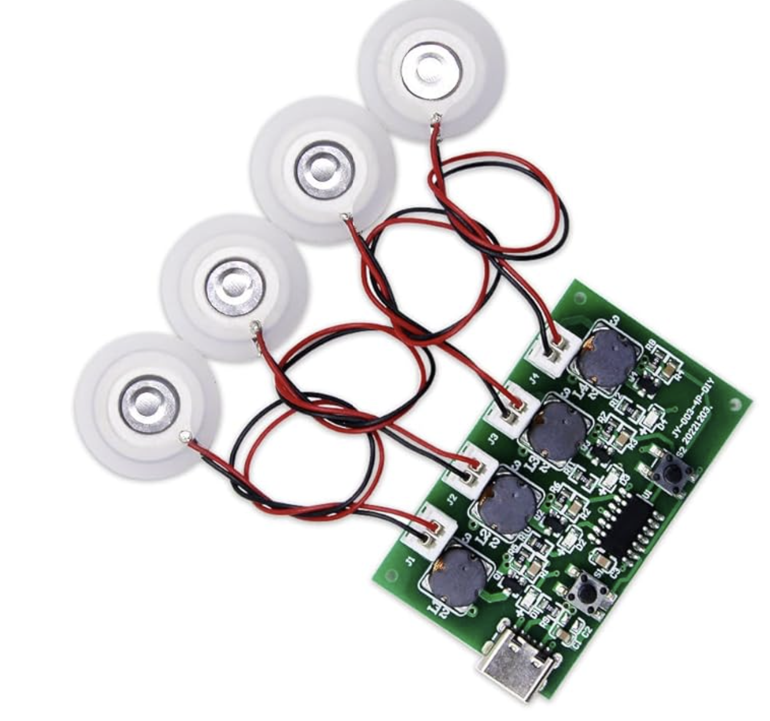

https://www.amazon.ca/Rotation-Turntable-3-speede-Recording-Application/dp/B09FPKP8QX/ref=asc_df_B09FPKP8QX?mcid=7bd1f1c033c53fc28bfbe506088faa24&tag=googleshopc0c-20&linkCode=df0&hvadid=706724917401&hvpos=&hvnetw=g&hvrand=3059102254765363573&hvpone=&hvptwo=&hvqmt=&hvdev=c&hvdvcmdl=&hvlocint=&hvlocphy=9001558&hvtargid=pla-2614660386192&psc=1&hvocijid=3059102254765363573-B09FPKP8QX-&hvexpln=0&gad_source=1

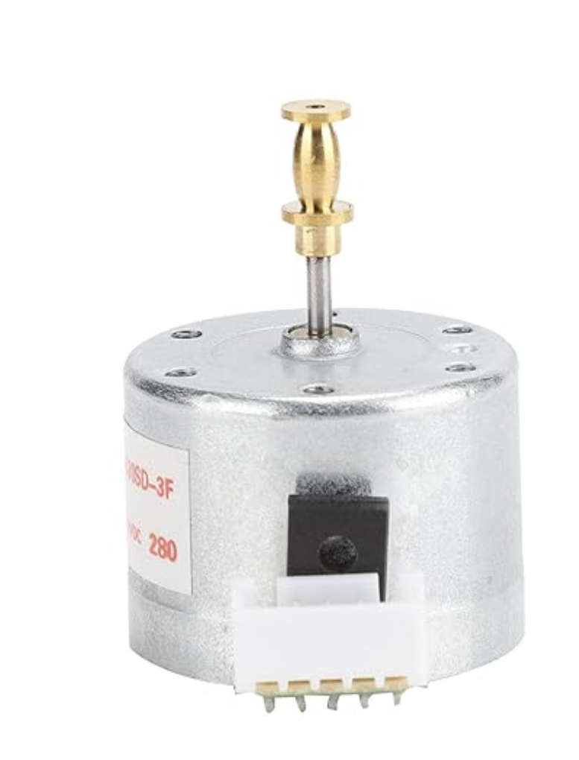

https://www.instructables.com/How-to-Make-a-Motorized-Lazy-Susan-With-a-Secret/

4 important aspects of the project
- Mechanical
  - Rotating base
    - How do we rotate the base?
    - Speed and factors that can affect plant growth.
  - Tower
    - Design of the tower.
  - Mist Sprayer System
    - How many mist sprayers do we need, and how do we attach them to the tower?
    - Do we include the nutrients in the mist with the water?
    - Do we need to buy a water pump or use the existing one in the lab?

- Sensing/Electrical/Control
  - How can we ensure that each plant can obtain an equal amount of water and nutrients?
  - How can we sense how much water or nutrients are needed for each plant?
  - Controller to be able to rotate and control the mist sprayer output to the plant.
  - How much power is needed to be able to operate the whole thing?

- Plant Growth
  - How does the plant grow? (Orientation)
  - Humidity, temperature, light, and nutrient intake are needed for the plant to ensure proper growth.
  - How do we design the tower to ensure the plant will not droop down?

- Data Collection
  - How can we gather data and monitor the growth?

To Ask Dr. Kim
- Is there a sensor in the lab that we can use to know the plant health?
- Do we integrate the nutrient machine in the lab with our project?
- Is it possible to have a greenhouse visit to know how to grow the cherry tomato?

Materials to Buy/Need
- PETG (used for the tower)
- Ultrasonic Mist Sprayer (Tim’s Idea)
- Bolts and nuts if needed
- Materials for DIY turntable (for rotating base, Lazy Susan style)
- Motor
- Arduino (or any other for controlling)
- Wires
- Water tubes
- Metal shafts for support if needed
- Sponges
- Sensors to monitor plant; if needed (pH sensors, CO2 sensors, Humidity and Temperature sensor)

https://sowrightseeds.com/blogs/planters-library/how-to-grow-use-cherry-tomatoes
https://www.thespruce.com/growing-and-caring-for-cherry-tomatoes-5078331

Notes:
Humid first 5 to 10 days
Warm and moist soil
Consistent 50 to 60 degrees Fahrenheit
At least 6 hours of sunlight
Prefer lower pH soil (6 - 6.8)
2-3 feet apart
Heavy Feeder, lower nitrogen, so better fruits
Soil type: Loamy and well-drained
Water regularly, moist but not overwatered

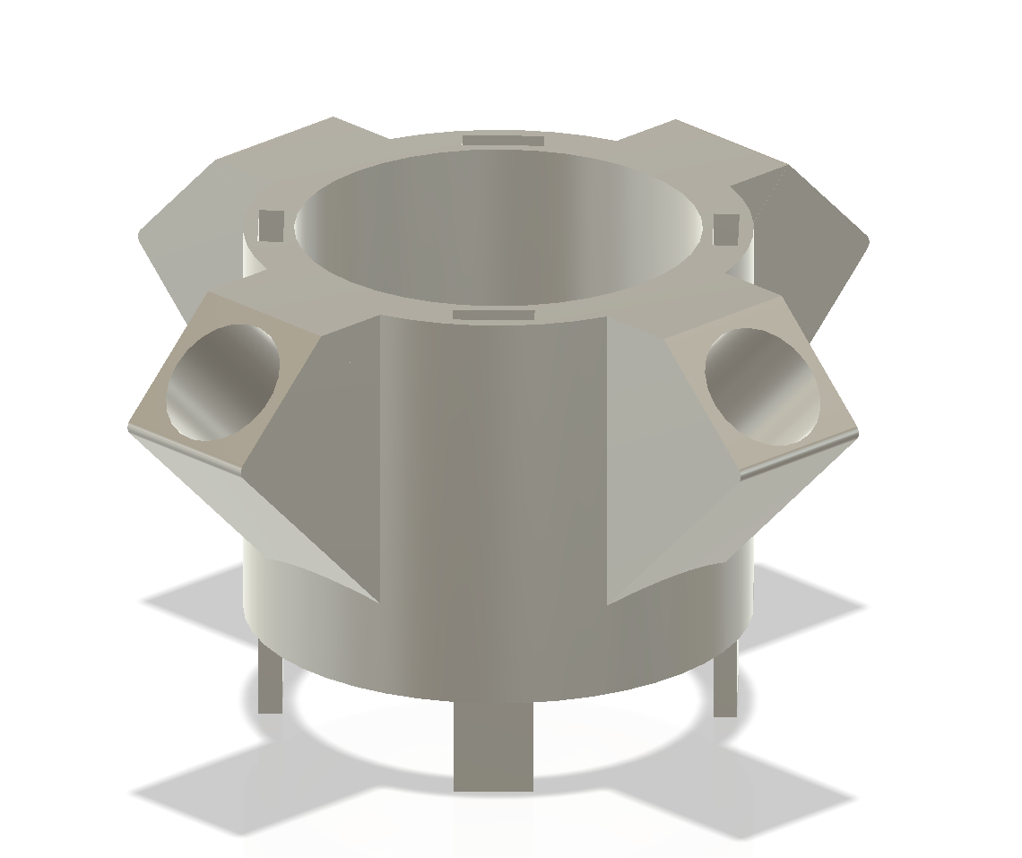
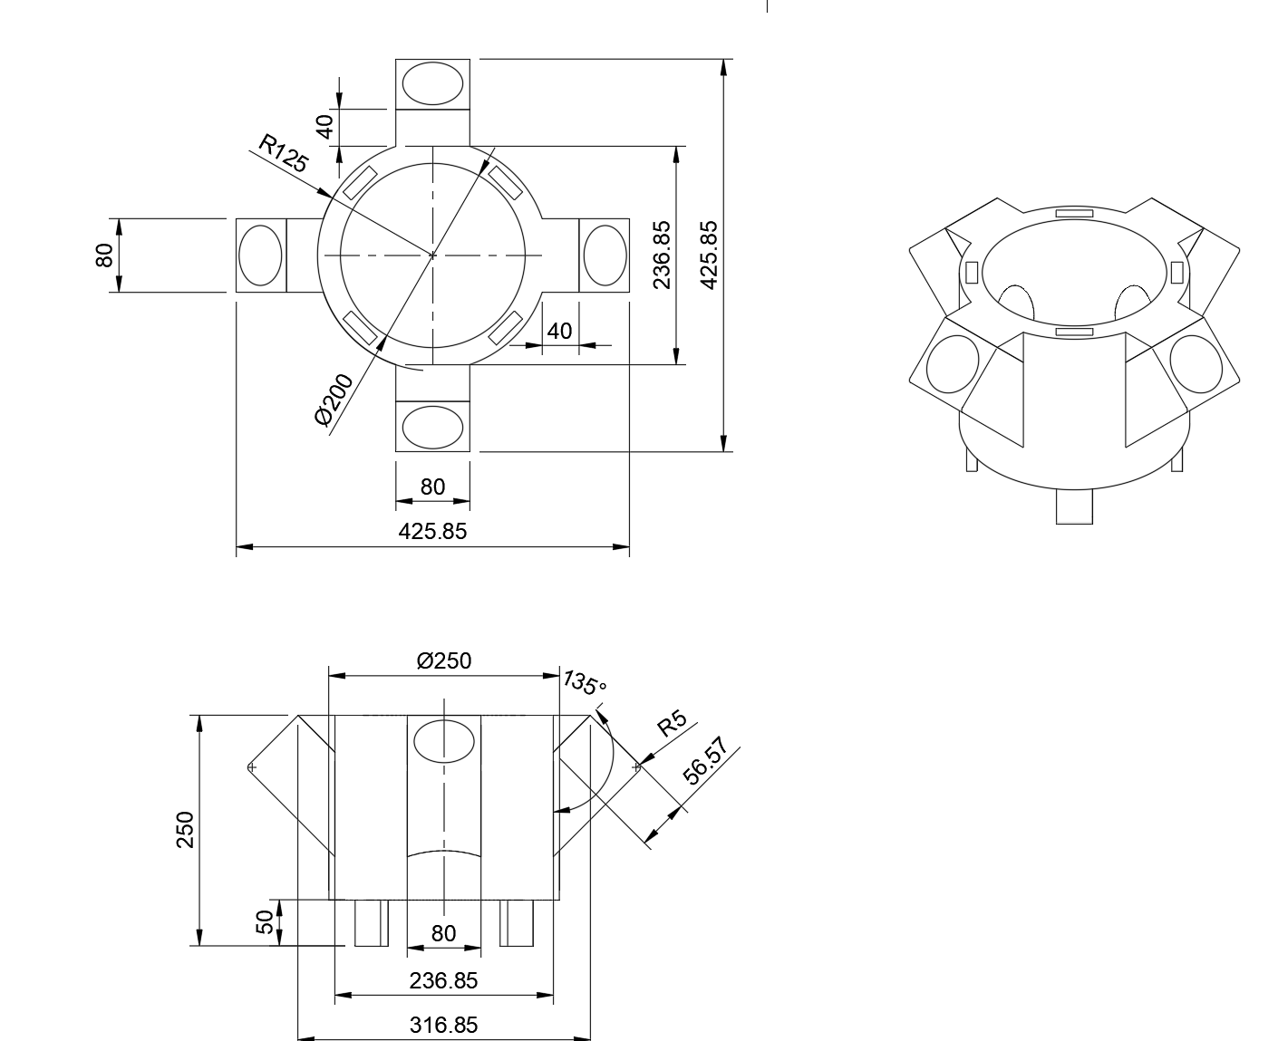
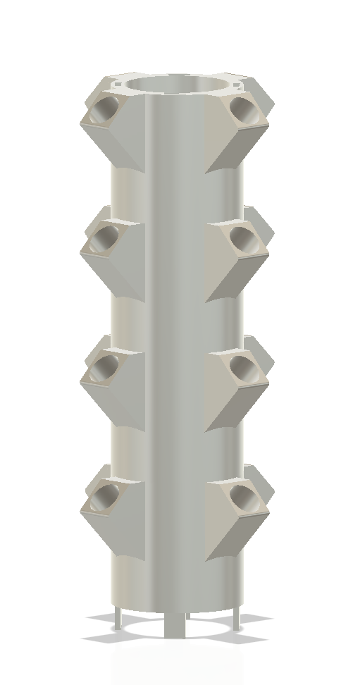

Ricky's Draft
https://www.amazon.ca/Hydroponics-Vertical-Hydroponic-Pineapple-Aeroponic/dp/B0CHY3L8QZ/ref=asc_df_B0CHY3L8QZ?mcid=bfcf2ee1bfad3e48b56e4313def931ed&tag=googleshopc0c-20&linkCode=df0&hvadid=706745350930&hvpos=&hvnetw=g&hvrand=12569465397150754161&hvpone=&hvptwo=&hvqmt=&hvdev=c&hvdvcmdl=&hvlocint=&hvlocphy=9001558&hvtargid=pla-2274912562684&hvocijid=12569465397150754161-B0CHY3L8QZ-&hvexpln=0&th=1

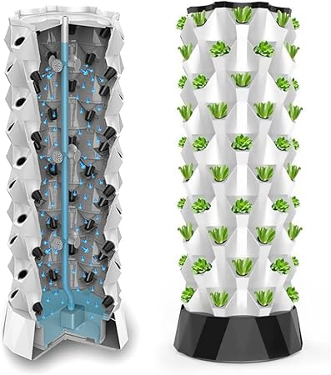

https://www.amazon.ca/ZORZA-Four-Spray-Humidifier-Versatile-Atomizer/dp/B0CYZJR2G4/ref=asc_df_B0CYZJR2G4?mcid=a1189d1f8b3a3cb68a25e30090b41787&tag=googleshopc0c-20&linkCode=df0&hvadid=706745545657&hvpos=&hvnetw=g&hvrand=1782441431643153603&hvpone=&hvptwo=&hvqmt=&hvdev=c&hvdvcmdl=&hvlocint=&hvlocphy=9001558&hvtargid=pla-2307969408675&psc=1&hvocijid=1782441431643153603-B0CYZJR2G4-&hvexpln=0&gad_source=1


https://www.amazon.ca/Rotation-Turntable-3-speede-Recording-Application/dp/B09FPKP8QX/ref=asc_df_B09FPKP8QX?mcid=7bd1f1c033c53fc28bfbe506088faa24&tag=googleshopc0c-20&linkCode=df0&hvadid=706724917401&hvpos=&hvnetw=g&hvrand=3059102254765363573&hvpone=&hvptwo=&hvqmt=&hvdev=c&hvdvcmdl=&hvlocint=&hvlocphy=9001558&hvtargid=pla-2614660386192&psc=1&hvocijid=3059102254765363573-B09FPKP8QX-&hvexpln=0&gad_source=1



https://www.instructables.com/How-to-Make-a-Motorized-Lazy-Susan-With-a-Secret/

4 important aspects of the project
- Mechanical
  - Rotating base
    - How do we rotate the base?
    - Speed and factors that can affect plant growth.
  - Tower
    - Design of the tower.
  - Mist Sprayer System
    - How many mist sprayers do we need, and how do we attach them to the tower?
    - Do we include the nutrients in the mist with the water?
    - Do we need to buy a water pump or use the existing one in the lab?

- Sensing/Electrical/Control
  - How can we ensure that each plant can obtain an equal amount of water and nutrients?
  - How can we sense how much water or nutrients are needed for each plant?
  - Controller to be able to rotate and control the mist sprayer output to the plant.
  - How much power is needed to be able to operate the whole thing?

- Plant Growth
  - How does the plant grow? (Orientation)
  - Humidity, temperature, light, and nutrient intake are needed for the plant to ensure proper growth.
  - How do we design the tower to ensure the plant will not droop down?

- Data Collection
  - How can we gather data and monitor the growth?

To Ask Dr. Kim
- Is there a sensor in the lab that we can use to know the plant health?
- Do we integrate the nutrient machine in the lab with our project?
- Is it possible to have a greenhouse visit to know how to grow the cherry tomato?

Materials to Buy/Need
- PETG (used for the tower)
- Ultrasonic Mist Sprayer (Tim’s Idea)
- Bolts and nuts if needed
- Materials for DIY turntable (for rotating base, Lazy Susan style)
- Motor
- Arduino (or any other for controlling)
- Wires
- Water tubes
- Metal shafts for support if needed
- Sponges
- Sensors to monitor plant; if needed (pH sensors, CO2 sensors, Humidity and Temperature sensor)

https://sowrightseeds.com/blogs/planters-library/how-to-grow-use-cherry-tomatoes
https://www.thespruce.com/growing-and-caring-for-cherry-tomatoes-5078331

Notes:
Humid first 5 to 10 days
Warm and moist soil
Consistent 50 to 60 degrees Fahrenheit
At least 6 hours of sunlight
Prefer lower pH soil (6 - 6.8)
2-3 feet apart
Heavy Feeder, lower nitrogen, so better fruits
Soil type: Loamy and well-drained
Water regularly, moist but not overwatered

Types of patio tomato
Tiny Tim, Patio Princess, Red Robin (Best one cause of height, weight, and ease of growth)




Nam's Draft



1. The Rotating Mechanism (Mechanical Reference)
Project: Rotating Modular Hydroponics garden by Wick3D
- Platform: Printables
- Link: Rotating Modular Hydroponics garden by Wick3D
- Why: Inspect the Base_Module and the Swivel_Adapter parts. This is the only popular open-source design that successfully solves the "rotating water seal" problem.

2. The Tower Structure (Base Geometry)
Project: Modular Hydroponic Tower (Remix by blove)
- Platform: Printables
- Link: Modular Hydroponic Tower by blove
- Why: This is the most refined version of the standard tower.

3. The IoT & Logic (Code Reference)
Project: ESP32 Greenhouse Tower DIY by ZanzyTHEbar
- Platform: GitHub
- Link: ZanzyTHEbar/ESP32GreenhouseTowerDIY
- Why: Even though we are using Arduino/Pi, review the greenhouse.py or C++ logic here. It contains the structure for sensor-based triggers (e.g., "If humidity < X, mist for Y seconds") which you can port to your Arduino sketches.

1. High-Pressure Nozzle Fitting (The "Leak-Proof" Part)
- Project Name: Aeroponic Mister fitting by CartesianTheatrics
- Link: Printables - Aeroponic Mister fitting
- Context: This is the specific geometry tested at 120 PSI. Download this STL/STEP file and "remix" it into the wall of your main tower modules to ensure your 0.1mm nozzles don't leak.

2. The Structural Core (PVC Compatible)
- Project Name: Modular Hydroponics Tower: Ebb & Flow by Beadsworth
- Link: Thingiverse - Modular Hydroponics Tower
- Context: Use this as your base "body." It is designed to slide over a standard Schedule 40 PVC pipe (which matches your 2.5m tower requirement).

3. The Rotary Union (Metal Safety Part)
- Resource: Deublin Rotating Unions CAD Catalog
- Link: 3Dfindit - Deublin Rotating Unions
- Context: Do not print this part. Use this catalog to find a STEP file (look for "Water Service" or "General Purpose" unions) to import into Fusion 360 so you can design a precise bracket to hold the metal union you will buy.

4. Complete System Reference (Plumbing Logic)
- Project Name: Micro-Hydroponic / Aeroponics Garden by Izak Francois Smit
- Link: GrabCAD - Micro-Hydroponic / Aeroponics Garden
- Context: Download this to inspect the internal plumbing and manifold design. It is a rare example of a "true aeroponic" CAD assembly.

Tim's Draft
Draft
How to grow a Cherry tomato plant:
Humid first 5 to 10 days
Warm and moist soil
Consistent 50 to 60 degrees Fahrenheit
At least 6 hours of sunlight
Prefer lower pH soil (6 - 6.8)
2-3 feet apart
Heavy Feeder, lower nitrogen, so better fruits
Soil type: Loamy and well-drained
Water regularly, moist but not overwatered

Sites:
https://agrotonomy.com/aeroponic-tomatoes-on-a-tower-garden/\
https://sowrightseeds.com/blogs/planters-library/how-to-grow-use-cherry-tomatoes
https://www.thespruce.com/growing-and-caring-for-cherry-tomatoes-5078331

